**Narrative Report**

1. **What do you consider your greatest success of the past 6 months? Why?**

过去6个月里，我认为团队最大的成功在于设计了一款让大家期待的产品，这里的大家既包含自闭症儿童家庭，自闭症康复训练机构，还包含我们团队的所有成员，业内的专家，以及其他从业者等等。产品设计方面，我们结合专家和用户的调研意见，反复修改训练内容和教学方法，最终给出了PRD，即将进行Android和服务端的开发。

产品设计过程中，我们了解到大量潜在用户的诉求，这使我们愈来愈明确这个项目的意义所在。

Yuudee2最大的特点就是自动化，希望采用多点触摸设备所提供的虚拟强化方式（完全区别于线下ABA教学中的小食品，小物品）即可驱动学生的参与和主动学习，通过结构化的课件组织让儿童可以通过多感官人机交互更有效的掌握知识。解放家长的同时，实现了低到中等功能的自闭症儿童的独立学习，希望这样的尝试能对自闭症儿童及家庭有所帮助。

另一方面，根据CDC最新统计，自闭症患病率已经从1/68增长到了1/59，而目前国内康复师的资源还非常有限，远远不能满足自闭症儿童密集训练的需求。随着电子设备的普及，希望在电子设备的载体下，Yuudee2可以成为许多没有老师训练资源的自闭症儿童的一个自主有效学习的工具。

1. **What was your biggest failure and what did the team learn from it?**

谈不上失败，但的确有一些比较遗憾，我们也许可以做的更好的地方：

1、没有中文PIADS量表，我们不得不耗费大量的时间和精力去设计一份符合需求的量表。

2、Google analytics is not available in China, 所以在数据收集功能和上传数据到UNICEF官网功能的技术实现上，我们将需要比其他团队多投入一些时间和精力，做一些从数据导出、格式化等工作。

3、项目第一季度的调研过程记录相对粗糙，而且宣传力度比较低。

1. **List each milestone from the agreed Project Workplan and provide a summary of the progress made against each. Tell us what the real-time data has been showing (what results can we draw from the data). What other data have you collected and analyzed to measure your success and progress.**

Quarter 2

**Milestone 1: Basing on the selected style, draw pictures for six difficulty level,10 pictures for each level.**

我们选择了手绘风格，画完了全部的训练图片，总量超过了200张。训练图片内容包含了中文动词结构、名词结构和句子。Here are the details:

1、完成了218张核心图片的手工绘制工作。

根据训练语料的设计，我们选择了其中最核心的绘画图片218张，由大龄自闭症青年李梓洋手工绘制完成。之后的图片处理工作由UI设计师完成。

2、完成了所有图片的用户调研工作。

在李梓洋绘制图片的过程中，采取了边绘制边调研的方法，把每天完成的图片发给目标人群自闭症儿童家庭做调研。让孩子按照指导语回答问题，看图片能否被多数小朋友认识。有的图片经过了反复地修改，比如“男孩吃面包”，在调研中发现很多孩子看到图片说男孩在吃轮胎，男孩在吃橘子等。为此，我们多次重绘图片，达到了80%儿童都能正确识别这个图片，保证图片可以有效辅助儿童训练。

link：

<https://github.com/xiaoyudi-China/xiaoyudi_iOS/tree/master/symbolset>

**Milestone 2: Complete the prototype design of the Yuudee2 product**

According to the product definition, the prototype of the product is designed to form the second draft; Discuss the prototype drawing with the product director and adjust it.

1. 产品的原型图和PRD已更新到第4版；

2、评估量表设计：

我们邀请了英国约克大学心理学博士陈思浓(目前在北京大学做研究人员)帮助设计Yuudee2效果评估的问卷设计。经过3个多月的调研、讨论和修订，目前陈博士设计了PCDI量表必做版和选做版作为产品词汇和语言结构训练是否有效的依据；同时陈博士也设计了自闭症症状量表来测试此产品是否在自闭症儿童的行为症状上是否有效。

3、产品设计调研：

为保证产品的训练形式能够满足自闭症儿童的训练需求，我们多次请教中国的自闭症专家探讨训练方式的有效性。为保证本产品的交互设计和逻辑，我们组织产品设计人员和开发人员对本产品进行评审，并基于大家的意见和建议修订了产品设计。

link:

<https://github.com/xiaoyudi-China/xiaoyudi_iOS/tree/master/product_design/Prototype_20180617>

(如需查看，需要使用axure软件，或者使用安装了axure插件的浏览器)

**Milestone 3: UI design and technical architecture design**

Activity 1: Product manager and UI discuss the interface design style of the whole product and start interface design.

At present, the UI design has completed the main visual design, and left pages are expected to be completed by the end of this month.

Link: Finished Yuudee2 product UI design first draft V1.0.0

<https://github.com/xiaoyudi-China/xiaoyudi_iOS/tree/master/product_design/UI>

Activity 2: The CTO builds the technical framework according to the prototype of the product.

Based on the current product requirements document, the server-side technical architecture was given, using the classic MVC model, open source database and cache services, and the service module in back-end code is divided based on product modules. The server will provide services to the client in the form of restful API; the client supports online and offline use, and when connecting to the network, it can send usage data to the server.

Link:

<https://github.com/xiaoyudi-China/xiaoyudi_iOS/blob/master/docs/BackendTechnicalArchitectureDraft.md>

**Milestone 4: Cohort Product Development**

Contribute all product design and code to github repository. Includes: 1.The final determination of the pattern of product picture at all levels 2.PRD 3. UI interface design and technical architecture.

Please refer to the link in milestone 1,2,3.

**Milestone 5: Development and Integration**

Activity 1: Development of and integration of data collection/analytics tools

Signs of Success: Determine the data collection/analytics tools(currently we determine to use Baidu analytics); Determine what kind of data should be collected that won't violate Chinese law and regulation; Design data collection function in Yuudee 2.

The statistical indicators of the app and backend management system are summed up, and the corresponding product design work has been completed:

(1) app statistics are divided into two major modules: user learning files (cumulative values and trend graphs) and training effects (the relationship between scale scores and learning duration/testing progress);

(2) backend management system statistics are divided into three major modules: platform user data (cumulative values and trends, user details), training method effectiveness analysis, courseware difficulty statistic

Activity 2: Integration of a web-based form of the PIADs scale: Design online PIADs scale test function in Yuudee 2

We have done a lot of research works on this activity, however, we could not find any Chinese version PIADS scale. Finally, we designed a scale based on the opinions of experts.

(TODO 补充思浓的调研和设计路径)

目前我们的量表分为两部分，第一部分参考了PCDI(Putonghua Communicative Development Inventory)量表进行设计，用于评估自闭症儿童的中文词汇和语言结构是否提高，并且对这部分做了分级设计，包括PCDI量表必做版和选做版；第二部分是自闭症症状量表，用来评估自闭症儿童的行为症状的改善情况。

link：

<https://github.com/xiaoyudi-China/xiaoyudi_iOS/blob/master/product_design/PCDI(%E6%B1%89%E8%AF%AD%E6%B2%9F%E9%80%9A%E5%8F%91%E5%B1%95%E9%87%8F%E8%A1%A8---%E8%AF%8D%E6%B1%87%E5%8F%8A%E5%8F%A5%E5%AD%90(16%E6%9C%88%E9%BE%84%E4%BB%A5%E4%B8%8A)).xlsx>

**Milestone 6: Meeting Open Source Contractual Requirement**

Activity 1: Providing repositories meeting open source requirements

Sign of success: Providing READ.md, CONTRIBUTE.md, license, issue repositories and other elements meeting open source requirements in Yuudee 2 project in github.

Link: <https://github.com/xiaoyudi-China/xiaoyudi_iOS>

本仓库主要包含以下目录：

docs: 文档，包含但不限于product proposal, MRD, business model等

symbolset: first draft symbol set

product_design: PRD, prototype, test scale, UI design等

iosapp: iOS code

communication: 一部分宣传材料

LICENSE: [GNU General Public License v3.0](https://github.com/xiaoyudi-China/xiaoyudi_iOS/blob/master/LICENSE)

CONTRIBUTING.md: 协作指南

<README.md>: 项目简介

**Milestone 7: Communications and Branding**

Activity 1: 1 image + caption per month to be shared on your social media channels

Activity 2: 1 blog post at end of quarter

由于我们的产品目标用户为使用中文普通话的自闭症儿童，所以宣传材料全部使用中文。

Link:

Yuudee2 official website:

Let love continue to melt autism http://www.xiaoyudi.org/?p=2225

The willingness of Yuudee2 http://www.xiaoyudi.org/?p=2196

Weibo(like twitter in China):

https://weibo.com/p/1005056530669403/home?from=page_100505&mod=TAB&is_all=1#place

**Milestone 8: Product Design**

Activity 1: Develop product design roadmap using focus groups comprised of users (teachers, children)

训练图片采取了边绘制边调研的方法，把每天完成的图片发给目标人群自闭症儿童家庭做调研。让孩子按照指导语回答问题，看图片能否被多数小朋友认识。有的图片经过了反复地修改，比如“男孩吃面包”，在调研中发现很多孩子看到图片说男孩在吃轮胎，男孩在吃橘子等。为此，我们多次重绘图片，达到了80%儿童都能正确识别这个图片，保证图片可以有效辅助儿童训练。

**Milestone 9: Testing**

Activity 1: Develop and document testing roadmap to assess icons viability and development of iterations

同上.

1. **Please give us an update on your team and company: Changes in the team (new members, changes in roles and responsibilities or structure etc)**

New members:

Chen Sinong: 英国约克大学心理学博士陈思浓(目前在北京大学做研究人员)

Xing Mei, Han Wenjie: UI设计师,其中Xing Mei是小雨滴1的UI设计师

1. **New funding or investments that you have secured or have in the pipeline**

There is no new funding or investments.

1. **Number of users of your product**

xxx

1. **Your current product version and updated roadmap if applicable.**

xxx

1. **Revenue in the last months**

No revenue, we still in the phase of product development.

1. **Your current business strategy (complete an updated business model canvas):**

**Please use the filled out one below as guidance:**

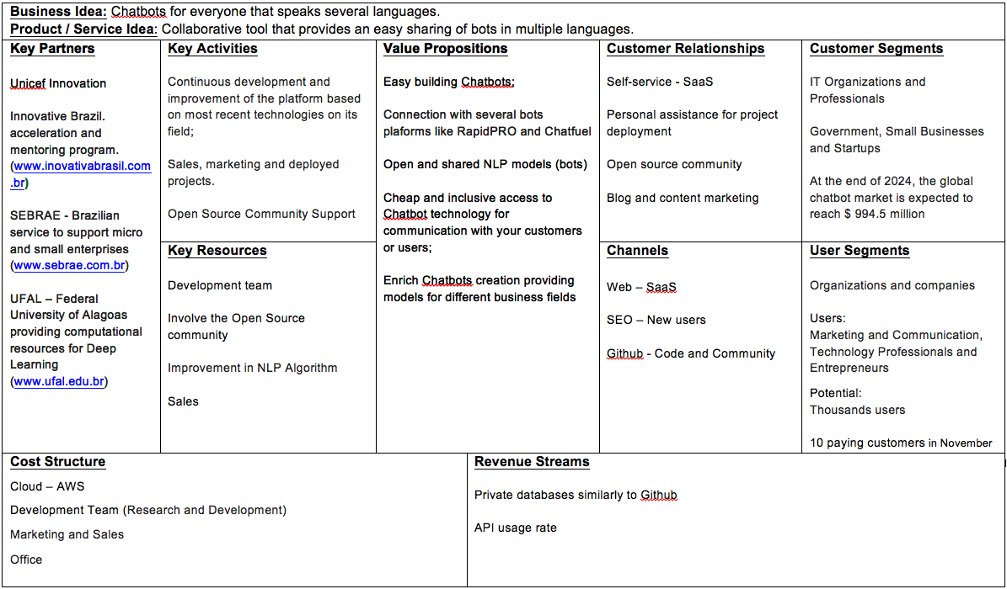

1. **New partnerships or stakeholders**

Their is no new partnerships or stakeholders.

1. **Links to any coverage or written materials (blogs, media, interviews) talking about the team / members / product**

Yuudee2 official website:

Let love continue to melt autism http://www.xiaoyudi.org/?p=2225

The willingness of Yuudee2 http://www.xiaoyudi.org/?p=2196

Weibo(like twitter in China):

https://weibo.com/p/1005056530669403/home?from=page_100505&mod=TAB&is_all=1#place